Chapter 14, Solution 45.

Convert the voltage source to a current source as shown below.

I_{s}
10 mH
50 μF
50 kΩ
30 kΩ

R = 30//50 = 30x50/80 = 18.75 kΩ
This is a parallel resonant circuit.
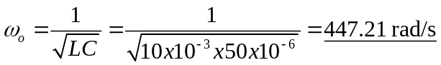
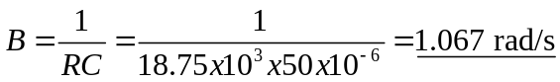
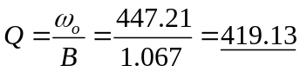

447.2 rad/s, 1.067 rad/s, 419.1

